Final paper Dm:

Show that the union of two countable sets is always countable.

<http://mathonline.wikidot.com/the-union-and-intersection-of-two-countable-sets-is-countabl>

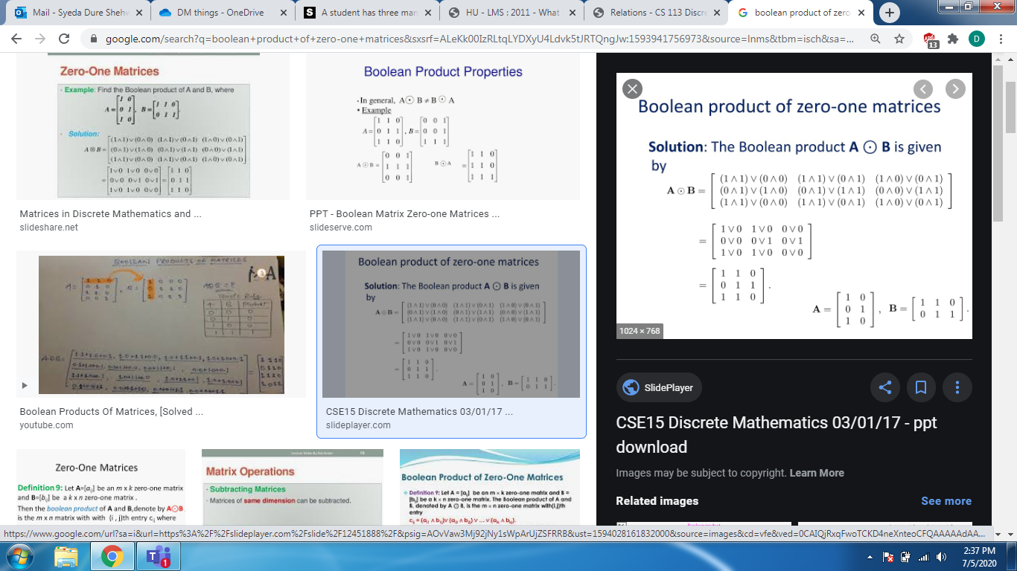

student has three mangoes, two papayas, and two kiwi fruits. If the student eats one piece offruit each day, and only the type of fruit matters, in how many different ways can these fruitsbe consumed?(

slader.com/discussion/question/a-student-has-three-mangos-two-papayas-and-two-kiwi-fruits-if-the-student-eats-one-piece-of-fruit-ea/

Show that among 5 people at a dinner table, there are two that have an identical number offriends among those at the table.

<http://www.cs.cornell.edu/courses/cs280/2002sp/pigeonhole%20problems.htm>

Prove the identity by counting two ways:(nr)(rk)=(nk)(n−kr−k

<http://discrete.openmathbooks.org/dmoi2/sec_propositional.html>

Show that ifa, b, canddare integers, wherea6= 0, such thata|candb|d, thenab|cd

<https://www.slader.com/discussion/question/show-that-if-a-b-c-and-d-are-integers-where-a-0-such-that-a-c-and-b-d-then-ab-cd/>

pointsUse the construction in the proof of the Chinese Remainder Theorem to find all solutionsto the system of congruences:x≡1(mod 2), x≡2(mod 3), x≡3(mod 5), andx≡4(mod 11).

<https://www.slader.com/discussion/question/use-the-construction-in-the-proof-of-the-chinese-remainder-theorem-to-find-all-solutions-to-the-sy-2/>

Draw the following graphs:(a)K7(b)C8(c)K2,8(d)W6

<https://zdaugherty.ccnysites.cuny.edu/teaching/mA6800f15/handouts/HW9.pdf>

Show that the property that a graph is bipartite is an isomorphic invariant.

<https://www.slader.com/discussion/question/show-that-the-property-that-a-graph-is-bipartite-is-an-isomorphic-invariant/>

Show thatif all vertices in a graph G are of degreen≥2, then G contains a cycle oflength at least n+1.P

<https://books.google.com.pk/books?id=c0BZDwAAQBAJ&pg=PA241&lpg=PA241&dq=Show+that+if+all+vertices+in+a+graph+G+are+of+degreen%E2%89%A52,+then+G+contains+a+cycle+of+length+at+least+n%2B1.P&source=bl&ots=PYvzKOntW2&sig=ACfU3U2stqJFzxIrGo16JSQyY85I_4QeDA&hl=en&sa=X&ved=2ahUKEwiJ3sS27rXqAhVz5-AKHReCB48Q6AEwAHoECAoQAQ#v=onepage&q=Show%20that%20if%20all%20vertices%20in%20a%20graph%20G%20are%20of%20degreen%E2%89%A52%2C%20then%20G%20contains%20a%20cycle%20of%20length%20at%20least%20n%2B1.P&f=false>